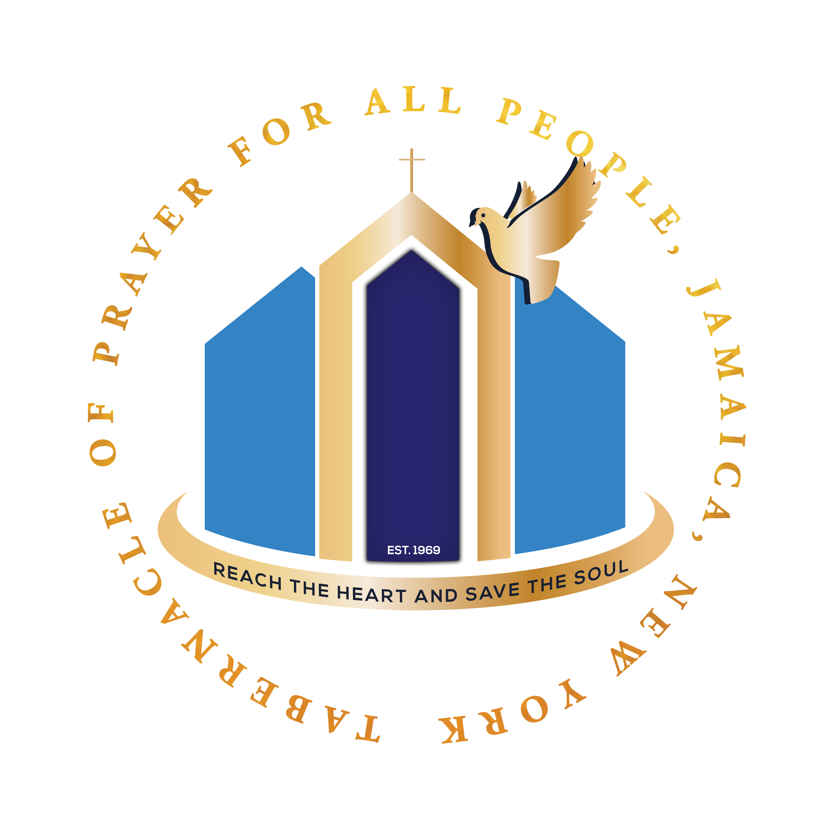
Consecration Bible Scripture Reading
APRIL-JUNE 2025
www.jamaicatab.org: “Consecration”
SUNDAY | MONDAY | TUESDAY | WEDNESDAY | THURSDAY | FRIDAY | SATURDAY
APRIL 20  JOEL 2:15  JOEL 1:13-14 | APRIL 21  JOEL 2:28-29  ACTS 2:15-21 | 22  ISA 42:8-10  ISA 43:11-15 | 23  HEB 4:12-16  PHIL 3:13-17 | 24  2 TIM 2:19-21  PSA 53:1-3 | 25  2 COR 5:17-21  1 COR 3:16-18 | 26  NAHUM 1:7  1 JOHN 2:1-6,10-11
27  JOB 19:25-26  1 COR 10:13 | 28  1 PETER 5:8-11  JAMES 1:2-8 | 29  1 PETER 1:22-25  EPH 5:1-10 | 30  1 COR 13:1-13  JOB 23:10 | MAY 1  1 JOHN 5:14-15  1 PETER 3:13-17 | 2  PSA 9:1-2  1 JOHN 2:15-17 | 3  JAMES 1:22-25  EPH 5:11-17
4  1 COR 6:19-20  1 COR 7:23-24 | 5  1 JOHN 4:1-4  EPH 3:4-12 | 6  EPH 4:13-19  JAMES 4:3,7,10,15 | 7  1 PETER 2:9-10  2 PETER 3:9,17-18 | 8  EPH 1:3-4  1 JOHN 3:22-24 | 9  GAL 5:1,16  1 COR 2:9-16 | 10  PHIL 4:13  PSA 51:10-13
11  EZEK 11:19-20  HEB 12:1-24 | 12  PHIL 4:6-9  ECC 12:13 | 13  EZEK 36:26-28  LAM 3:22-27 | 14  JUDE 24-25  GAL 6:9-10 | 15  1 PETER 4:12-13  1 JOHN 2:28-29 | 16  MATT 6:16-18  MATT 7:1 | 17  HEB 13:1-2,5,8  PSA 31:23-24
18  PSA 21:1-8  PSA 28:7 | 19  JER 23:23-24  1 THESS 4:1 | 20  JER 17:14  HEB 11:1,6 | 21  PSA 46:1-4  ISA 26:3-9 | 22  PSA 34:18  PSA 150:1-6 | 23  ISA 55:6-7  JAMES 4:3,10-17 | 24  MATT 6:5-8
25  JAMES 5:13-15  PSA 103:1-5 | 26  TITUS 2:1-8  PSA 33:18-22 | 27  1 COR 6:18  2 COR 4:8-10 | 28  JAMES 5:16  PSA 27:1-6 | 29  2 CHRON 7:14  LEV 19:2 | 30  EX 19:5-6  1 PETER 1:15-16 | 31  REV 15:3-4
JUNE 1  JOSHUA 1:8  ROM 8:35-37 | 2  PSA 100:1-5 | 3  ROM 8:28  ACTS 17:28 | 4  MATT 7:21-27 | 5  PSA 34:1-22 | 6  PSA 27:7-14 | 7  COL 3:16-17  ROM 8:26-27
JUNE 8 - Pentecost Sunday Acts 2:1-4

