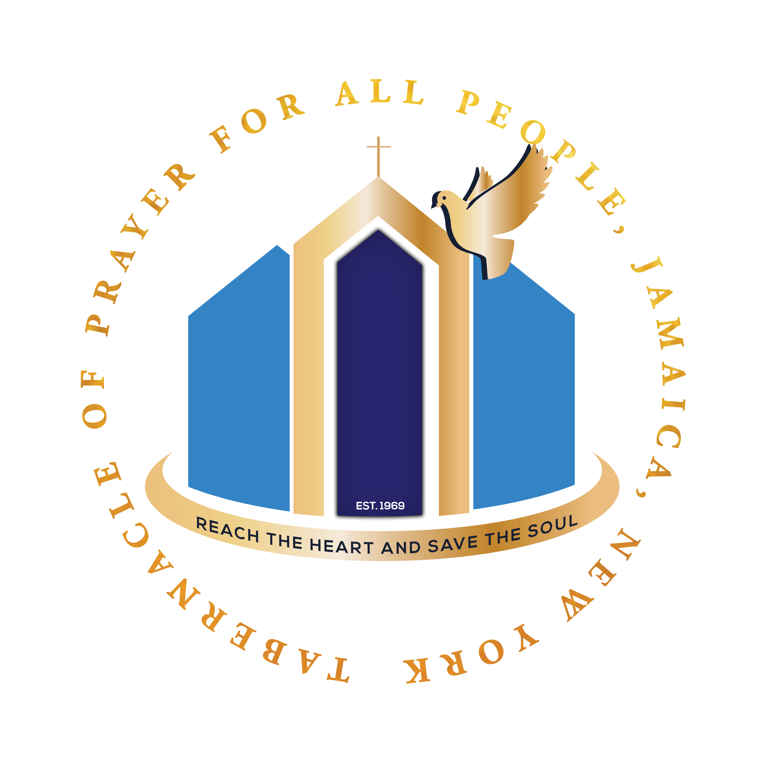
50 DAY CONSECRATION
The 50 Day Consecration was a vision given to our late Founder, Apostle Johnnie L. Washington, during the early years of this ministry and is still being carried out today. It is a vision from God for his people. All members of the body of Christ, regardless of denomination, are welcome to be a part of this consecration.

Beginning at midnight, Sunday, April 20, 2025 (12:01AM) we will begin the 50 Day Consecration by fasting each day until 5:00PM (no food or water), eating only one meal after 5:00PM, and praying at the church for one hour (7:00PM to 8:00PM) each day. Prayer is the strength of consecration.

In all services during the prayer hour, the dress code for men is dark pants, white shirts, and no ties; the dress code for women is white dresses [skirts and blouses] and white chapelettes on the head. (Cor 11:4-11)

CONSECRATION
Consecration is an act by a person or thing dedicated to the service and worship of God. Full consecration is the setting apart of oneself to God for the personal pleasure of God. (Eph 2:10)

FASTING
Fasting is the abstinence from food for a period of time. The custom of fasting has always played a part in the practices of every major religious group at some time. It has often been a way in which persons have sought pardon for their misdeeds. People also fast during times of mourning. It is believed that fasting will take one’s mind away from physical things and produce a state of spiritual joy and happiness. It has also been known to cleanse the body. (Joel 2:15-16; Matt 4:2; Jer 36:6)

PRAYER
Prayer is an offering up of our desires to God for the things lawful and needful with a humble confidence to obtain them only through the mediation of Christ, to the praise of the mercy, truth, and power of God. Prayer is our conversation to the Lord. (Luke 18:1; Matt 6:6; John 16:23-24; Luke 6:12)

WHY 50 DAYS?
The 50th day from Easter represents the 40 days Jesus walked on the earth after His resurrection plus the 10 days from the time of His ascension into Glory until the outpouring of the Holy Ghost. (Acts 2:4)

At the end of the 50 days, we celebrate “PENTECOST”. The word Pentecost is derived from the Greek word “fiftieth day”. Originally the festival was the time the first fruits were formally dedicated. Pentecost is one of the three main feasts of Israel. They were sacred festivals which were occasions of public worship. It was the events of the second chapter of Acts that transformed the Jewish festival into a Christian one. Pentecost is also known as “White Sunday” deriving its name from the white garments of those seeking baptism at this festival.

ON THE 50TH DAY, WE WILL CELEBRATE PENTECOST at the Tabernacle of Prayer Jamaica headquarters. All the fellowship churches, along with our friends, will gather together to lift up the name of Jesus.

And when the day of Pentecost was fully come, they were all with one accord in one place. And suddenly there came a sound from heaven as of a rushing mighty wind, and it filled all the house where they were sitting. And there appeared unto them cloven tongues like as of fire, and it sat upon each of them. And they were all filled with the Holy Ghost, and began to speak with other tongues, as the Spirit gave them utterance. – Acts 2:1-4

SCRIPTURES SUPPORTING FASTING
Joel 1:14, 2:15-16; Matt 4:2; 2 Cor 6:5, 11:27; Luke 2:36; Acts 14:23, 27:33

ALONG WITH FASTING - WE MUST PRAY- PRAYER IS STRENGTH TO THE CONSECRATION
Rom 12:12; 1 Peter 3:7, 12; Mark 11:25; Jude 20; Num 21:7; 1 Tim 2:8; Psalm 55:7; Luke 11:1;
James 5:16; 1 Cor 14:15; Col 4:2; Acts 16:13

